nFinia Digital Banking | Summerville Credit Union | Member User Guide
Card Alerts
Module: Banking › Cards › Card Details › Card Controls › Card Alerts

01 PRODUCT SUMMARY

Card Alerts puts you in control of how, where, and when your card is used. From the Card Alerts tab inside Card Controls, you can set spend thresholds that trigger alerts, and selectively enable or disable specific transaction types and merchant categories. Every toggle takes effect immediately — no waiting and no calls required.

At a Glance
Feature Name | Card Alerts
Module Location | Banking › Cards › Card Details › Card Controls › Card Alerts
Who Can Use | All nFinia Digital Banking members with an enrolled card
Spend Alerts | Set a per-transaction dollar threshold to flag large purchases
Transaction Types | In Store, Mail / Phone Order, ATM, eCommerce, Other, Grocery
Merchant Categories | Department Store, Gas Station, Household, Restaurant, Age Restricted, Personal Care
Changes Take Effect | Immediately upon saving
Availability | 24 / 7 — via web or mobile

02 KEY USE CASES

Use Case | Member Goal | Steps | Outcome
Set a spend alert threshold | Get notified when a transaction exceeds a set amount | Open Card Alerts, enable Per Transaction alert, enter dollar amount, save | Alert fires whenever a transaction exceeds the threshold
Disable ATM withdrawals | Prevent card from being used at ATMs | Under Transaction Type, toggle ATM to Off | ATM transactions declined instantly until re-enabled
Block eCommerce purchases | Stop online purchases while keeping in-store use active | Under Transaction Type, toggle eCommerce to Off | Online transactions blocked; physical purchases continue
Restrict merchant categories | Prevent card from being used at specific merchant types | Under Merchant Categories, toggle the category Off | Transactions at matching merchants are declined
Enable only specific categories | Allow card use only where the member needs it | Toggle desired Transaction Types and Merchant Categories On; leave others Off | Card works only at permitted merchant types

03 STEP-BY-STEP GUIDE

📍 Navigation path: Banking › Cards › [select card] › Card Details › Card Controls › Card Alerts tab

Step 1 Open Card Details
From the nFinia top navigation, select Cards. Locate the card you want to configure and click Card Controls at the bottom of that card tile. This opens the Card Details page.

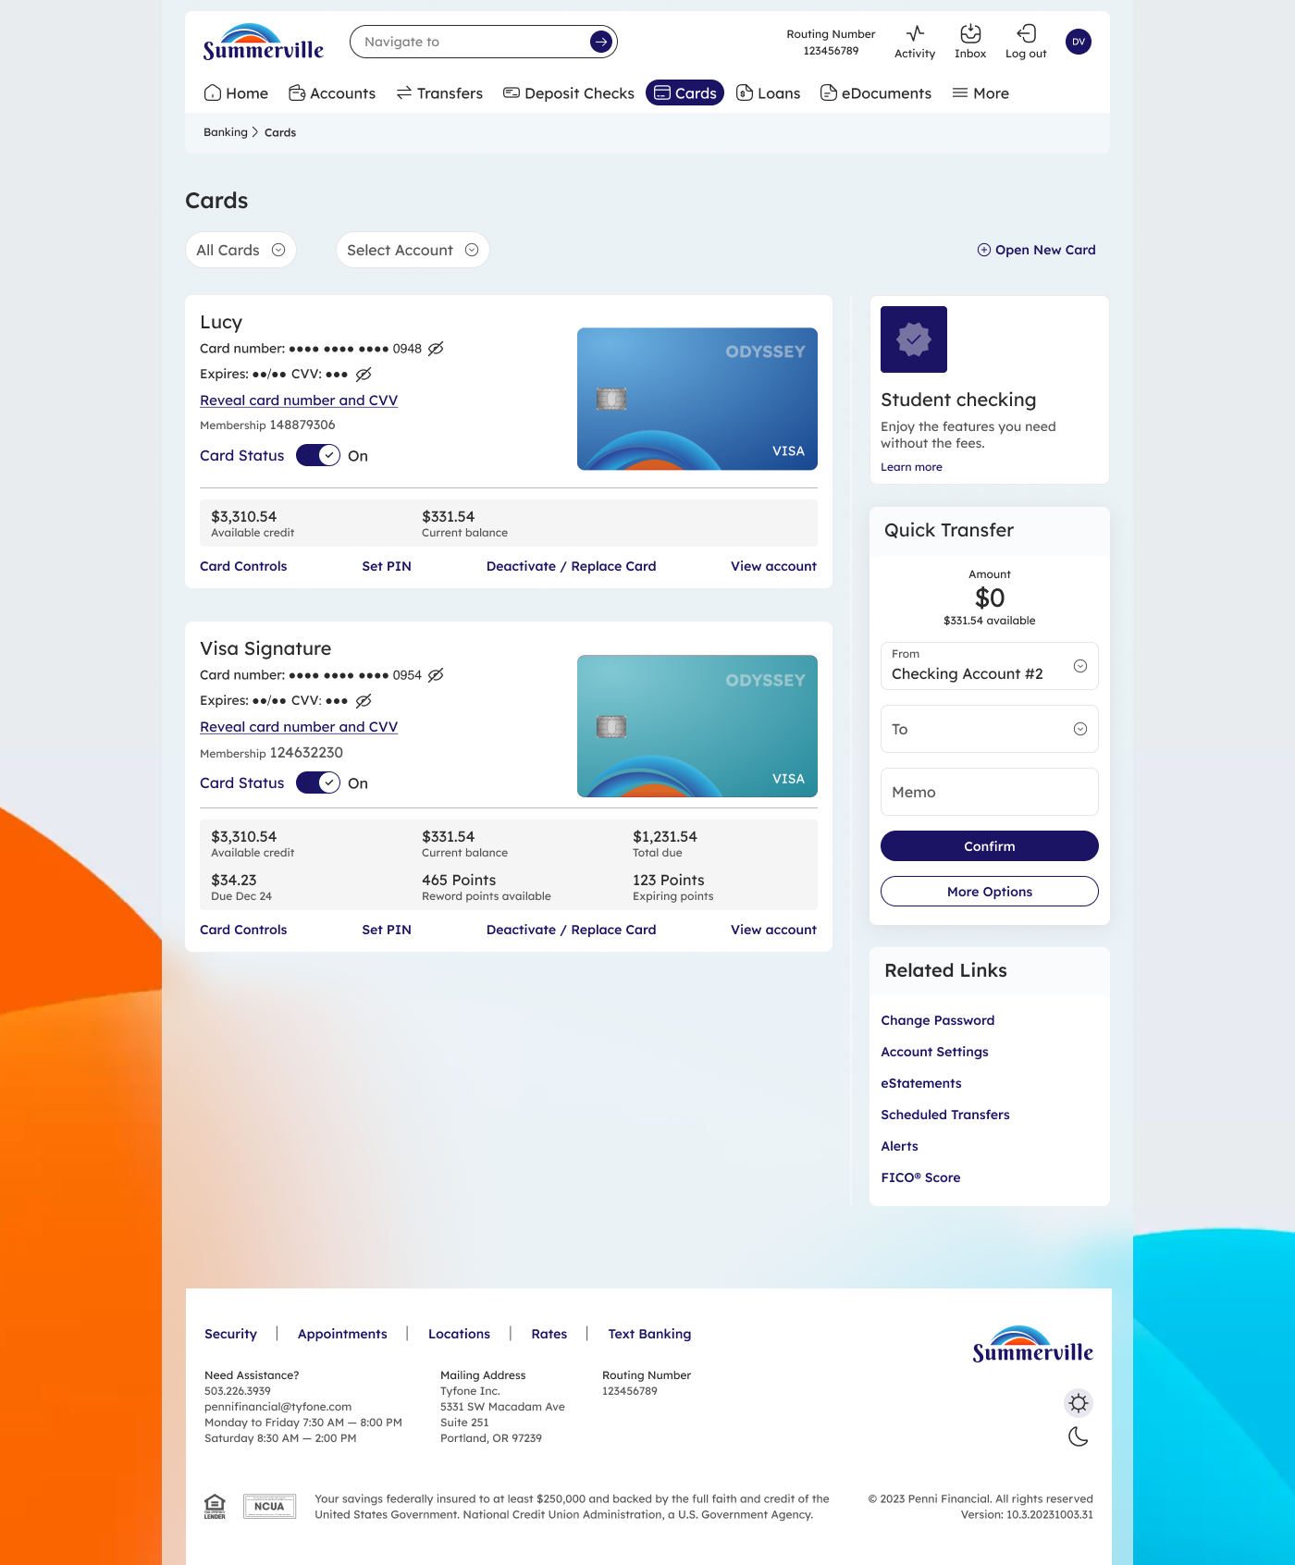

Step 2 Select the Card Alerts Tab
Inside Card Details, find the Card Controls section. Select the Card Alerts tab. The page will show two sub-sections: Spend Alerts at the top, followed by Transaction Type and Merchant Categories controls below.
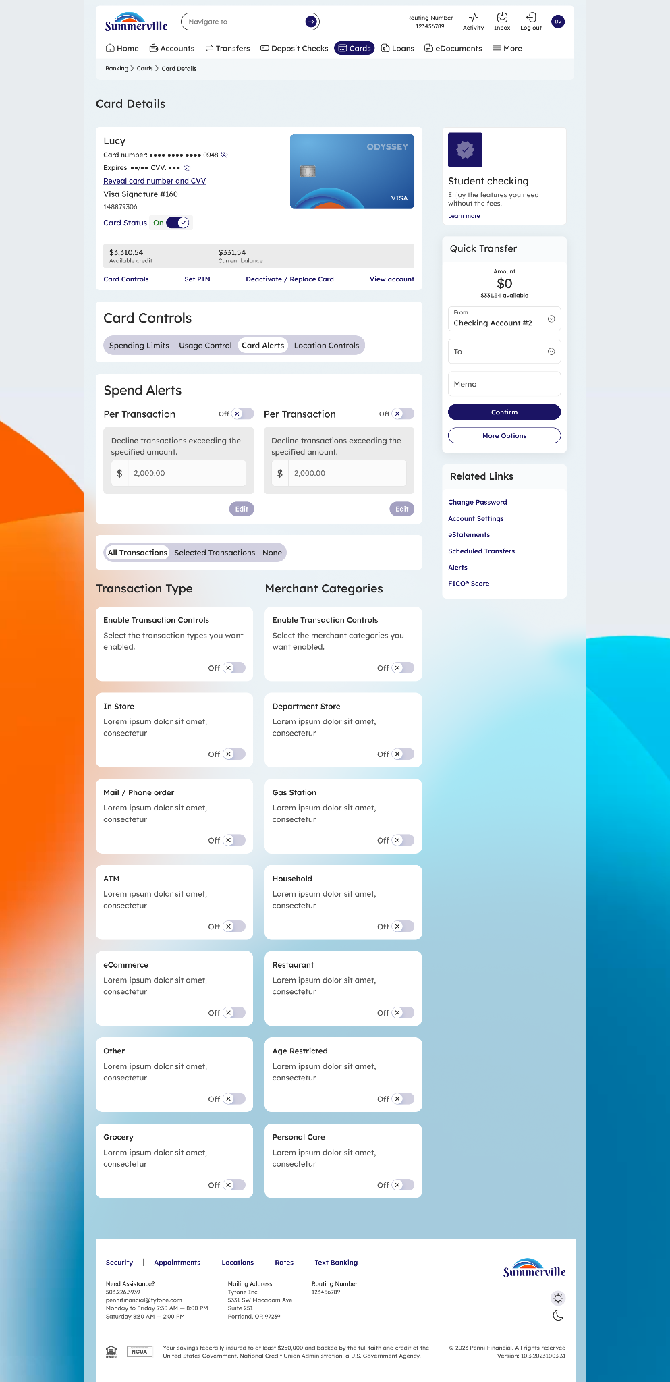

Step 3 Configure Spend Alerts
In the Spend Alerts section, you will see Per Transaction toggles. Toggle one On to activate a spend alert, then click Edit to set the maximum dollar amount. Any single transaction above this amount will trigger an alert notification.
ℹ️ Tip: You can set separate spend alert thresholds for different card types. Each card shows its own Per Transaction control.

■ Transaction Type Controls

The Transaction Type section lets you enable or disable specific ways your card can be used. Toggle any type Off to block that transaction method immediately.

Transaction Types | What it controls
In Store | Physical card-present purchases at retail locations
Mail / Phone Order | Orders placed by phone or mail using card details
ATM | Cash withdrawals and balance inquiries at ATMs
eCommerce | Online purchases and card-not-present transactions
Other | All other transaction types not listed above
Grocery | Purchases at grocery stores and supermarkets

■ Merchant Category Controls

The Merchant Categories section lets you control spending by merchant type. Toggle any category Off to block transactions at matching merchants instantly.

Merchant Category | What it controls
Department Store | Purchases at department and general merchandise stores
Gas Station | Fuel and convenience store purchases
Household | Home improvement, utilities, and household supply stores
Restaurant | Dining, cafes, bars, and food delivery services
Age Restricted | Merchants that sell age-restricted goods (e.g. tobacco, alcohol)
Personal Care | Salons, spas, pharmacies, and personal care services

⚠️ Note: Disabling a Transaction Type or Merchant Category blocks ALL cards on that account for that control. Changes are instant — ensure you intend to restrict the category before toggling Off.

ℹ️ Tip: To re-enable any control, simply toggle it back to On. There is no limit to how many times you can toggle alerts on or off.

